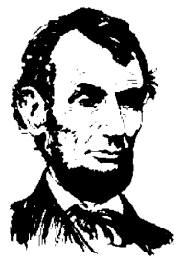

Lincoln County
Solid Waste Advisory Committee (SWAC)

Members |  | Sector | Tenure To
Marc | Torre | Hauler (Chair) | 4/2020
Ed | Dzedzy | Environmental Health (Co-Chair) | 4/2020
Mathew | Pederson | Hauler | 4/2020
Gene | Stuckle | Private | 4/2020
Scott | Deatherage | Business | 4/2020
Rob | Coffman | Lincoln County Commissioner | 4/2020
Margie | Hall | Business | 4/2020
Dean | White | Lincoln County Conservation Dist. | 09/2018
Jennifer | Zuber | Private | 10/2018
Justin | Slack | City of Harrington | 10/2018

